**Test a Perceptual Phenomenon - Stroop Effect**

The **Stroop effect** is a demonstration of interference in the [reaction time](https://en.wikipedia.org/wiki/Reaction_time) of a task. When the name of a color (e.g., "blue", "green", or "red") is printed in a color that is not denoted by the name (e.g., the word "red" printed in blue ink instead of red ink), naming the color of the word takes longer and is more prone to errors than when the color of the ink matches the name of the color.

# Background Information

In a Stroop task, participants are presented with a list of words, with each word displayed in a color of ink. The participant’s task is to say out loud the *color of the ink* in which the word is printed. The task has two conditions: a congruent words condition, and an incongruent words condition. In the *congruent words* condition, the words being displayed are color words whose names match the colors in which they are printed: for example RED, BLUE. In the *incongruent words* condition, the words displayed are color words whose names do not match the colors in which they are printed: for example PURPLE, ORANGE. In each case, we measure the time it takes to name the ink colors in equally-sized lists. Each participant will go through and record a time from each condition.

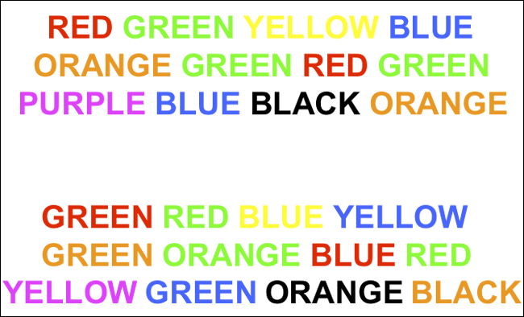

# Investigation

## Independent variable: Is the congruency condition including congruent words condition and incongruent words condition.

## Dependent variable:  Is the response time for each participant to name the font color.

# Hypotheses for this task, and statistical test need perform.

In this task, we can use hypothese as follow:

The null hypothesis is H0: there is no difference between the mean reaction time under congruent words condition and incongruent words condition. That is  μcongruent = μincongruent.

The alternative hypothesis is Ha: there is difference between the mean reaction time under congruent words condition and incongruent words condition. That is  μcongruent ≠ μincongruent.

Where, μcongruent: Population mean time in seconds to read the congruent words.

μincongruent: Population mean time in seconds to read the incongruent words.

To test the hypothesis, I use two-tailed paired t-test. Because one the test is non-direction, so the p-value is the two-tailed probability; two we need compare the means of two groups; three each participant is invovled under both conditions.

## Descriptive Statistics on Datasets:

|  |  |  |  |
| --- | --- | --- | --- |
| Congruency | Mean(time) | Median(time) | Standard deviation(time) |
| Congruent | 14.051125 | 14.3565 | 3.559357958 |
| Incongruent | 22.01591667 | 21.0175 | 4.797057122 |

Visualise and Comparing:

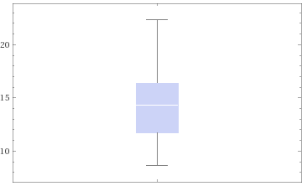 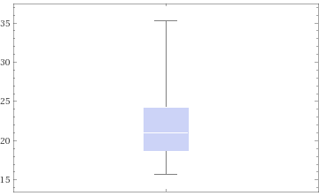

Combining both-

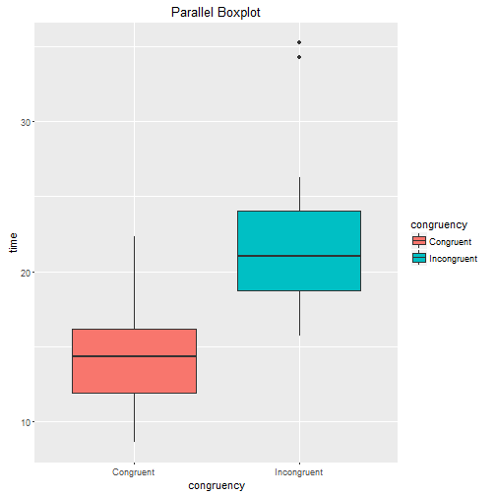

From the parallel boxplot above we can see that the incongruent group has higher median value than congruent group. And there are some outliers in the incongruent group.

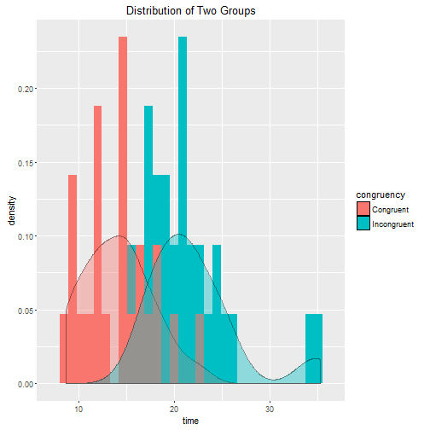

From the histogram with density plot we can see both groups have evident outliers, and the incongruent group spend longer time than congruent group.

Test result:

The t-test confidence level is 95%,n=24, t statistic value is t(23) = −8.021, the t-critical with two tail and 23 degree of freedom is t = +2.069,-2.069.

## **P Value Results**

T = -8.021   DF = 23

The two-tailed P value is less than 0.0001   
   By conventional criteria, this difference is considered to be extremely statistically significant.

(From[www.graphpad.com](http://www.graphpad.com))

So we reject the null hypothesis.

From the t-test result we can conclude that there is significant different between congruent group and incongruent group.

# Why?

https://faculty.washington.edu/chudler/gif/colors1.gifThe words themselves have a strong influence over your ability to say the color. The interference between the different information (what the words say and the color of the words) your brain receives causes a problem. There are two theories that may explain the Stroop effect:

1. Speed of Processing Theory: the interference occurs because words are read faster than colors are named.
2. Selective Attention Theory: the interference occurs because naming colors requires more attention than reading words.

More experiments to try- Turn the words upside down or rotate them 90 degrees.

# Reference:

1. [www.graphpad.com](http://www.graphpad.com)
2. [www.wolfram.com](http://www.wolfram.com)
3. faculty.washington.edu/chudler/words.html
4. Wikipedia
5. [www.github.com](http://www.github.com)
6. udacity